Press Release No:05/2022 Date: 12 September 2022
Venue: Addis Ababa, Ethiopia
Validation Workshop to support ten (10) African Union member states to create and/or improve National Energy Information System (NEIS), 12-14 September 2022, Addis Ababa, Ethiopia
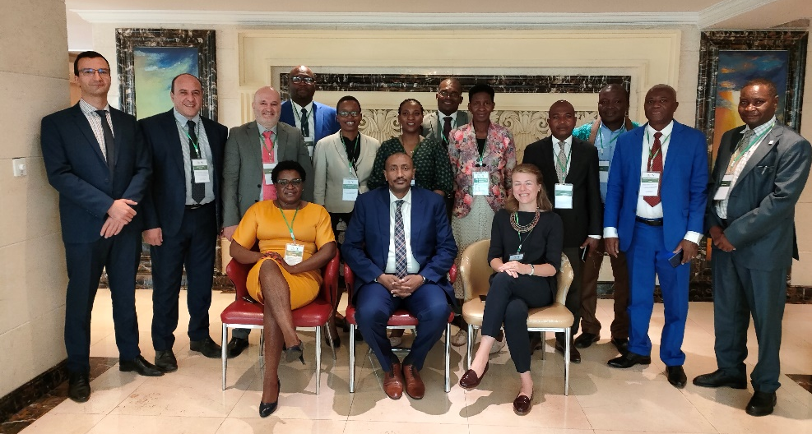
13 September 2022, Addis-Ababa, Ethiopia: The African Energy Commission (AFREC) hosted a validation workshop with senior national statisticians and various key stakeholders from Algeria, Botswana, Burkina Faso, Congo, Gabon, Kenya Lesotho, Namibia, Nigeria, and Zimbabwe to validate and provide input into countries Diagnostic report and Action Plan, to establish and/or improve their National Energy Information System (NEIS).
The validation workshop will enable the selected members States to analyse and validate the diagnostic report and action plan of their countries. The report and plan have been developed in the last eight months based on stakeholder interviews and supported by continual analysis of data and documentation shared by country focal points, with technical and financial support from AFREC.
In his opening remark, Mr. Rashid Ali Abdallah, Executive Director of AFREC stated that AFREC’s support programme on NEIS will increase the quality of the energy statistic processes which are significant indicators for developing energy policies, designing good strategies for investment, providing insights necessary for decision making at national level and finally to strengthen capacities of African countries energy experts in the methodology and tools for collecting and managing energy data.

The programme is aimed at building capacity of the aforementioned Member states to build and strengthen their NEIS, improve systems aimed at collecting and validating energy statistics, harmonizing and streamlining energy statistics processes across Member States and reinforcing the adoption of AFREC’s methodology on energy statistic and questionnaires.
The validated diagnostic reports and action plans for each country will serve as important execution tools for guiding the implementation of concrete recommendations to create or improve countries National Energy Information System (NEIS) of which ultimately will contribute to better energy planning.
# # # #
Notes to Editor
About the African Energy Information System
Since 2012, AFREC has put in place a platform named the African Energy Information System (AEIS) and a capacity building programme to support National Focal Points (NFPs) in the Member State, to coordinate energy data collection and validation at national level by using two questionnaires: Energy statistic (Energy Balance) and Energy efficiency for residential sector. In 2020, AFREC has conducted a comprehensive improvement of the AEIS and the new AEIS is now composed of the following elements: Profile of data collectors, Excel questionnaires (Data collection Tools), Data submission mechanism (online data collection), Data storage platform, Data dissemination and reporting system (publications and online data visualization tools) and Data managers and analysts (user interface for analysis dedicated to NFPs).
About the African Energy Commission
The African Energy Commission (AFREC) is a specialised energy agency of the African Union, mandated to implement African energy programmes by coordinating, harmonising, protect, conserve, develop, promote rational exploitation, commercialization, resource mobilisation and integration of energy resources for all AU Member states.
AFREC is also entrusted with the responsibility to design, create and set up the continental energy database, and facilitate rapid dissemination of information among AU member states, Regional Economic communities in Africa, investors amongst others.
For more information, please contact:
- Ms. Ndahafa Nakwafila| Communication and Information Specialist| African Energy Commission (AFREC) | African Union| email: NakwafilaN@africa-union.org| Tel: +213 23 45 9198 | email: afrec@africa-union.org| Website: www.au-afrec.org |Algiers|Algeria Follow Us: Facebook | Twitter
- Directorate of Information and Communication | African Union Commission I E-mail: DIC@africanunion.org I Website: www.au.int I Addis Ababa | Ethiopia

